Problem Statement:
Organizations often receive and maintain large amounts of employee information in external spreadsheets such as Excel. Transferring this data into ServiceNow manually can be time-consuming, repetitive, and prone to human errors. There is a need for an efficient and structured method to migrate bulk spreadsheet data into ServiceNow while maintaining accurate field mapping and data integrity.
This micro project addresses the problem by using ServiceNow Import Sets and Transform Maps. The spreadsheet data is first loaded into an Import Set Table, which acts as a temporary staging area. A Transform Map is then configured to map the source spreadsheet fields to the corresponding fields in the target ServiceNow table. After transformation, the imported records are created in the target table and validated for accuracy and completeness.

Example:
A company maintains employee details such as Employee ID, Employee Name, Email, Department, and Location in an Excel spreadsheet. When the company wants to add 500 employee records to ServiceNow, entering each record manually takes a lot of time and may cause errors.

Excel Spreadsheet:
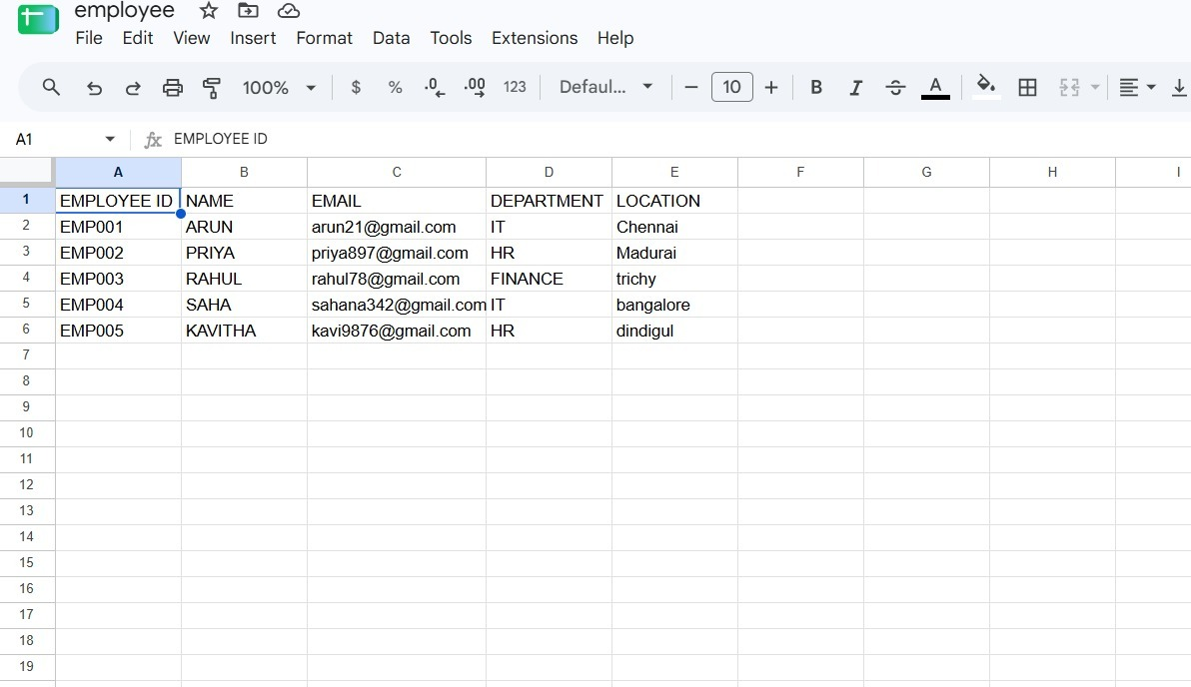
Instead of entering these records one by one, the organization needs a way to import the entire spreadsheet into ServiceNow, automatically map the fields, and create the corresponding records in the target table.

Solution flow:
Spreadsheet → Import Set Table → Transform Map → Target ServiceNow Table

